## SIMATS SCHOOL OF ENGINEERING

**SAVEETHA INSTITUTE OF MEDICAL AND TECHNICAL SCIENCES**

### CHENNAI-602105

Travel Blog Website

## A CAPSTONE PROJECT REPORT

*Submitted in the partial fulfillment for the award of the degree of*

# BACHELOR OF ENGINEERING

## IN

**COMPUTER SCIENCE AND ENGINEERING**

## Submitted by S.PRAKUL(192210073)

**S.DEVA(192210100)**

**Under the Supervision of Dr. VIVEK BALAJI**

# DECLARATION

I,S.PRAKUL,S.DEVA, students of **‘Bachelor of Engineering in Computer Science and Engineering**, Department of Computer Science and Engineering, Saveetha Institute of Medical and Technical Sciences, Saveetha University, Chennai, hereby declare that the work presented in this Capstone Project Work entitled **Travel Blog Website** is the outcome of our own Bonafede work and is correct to the best of our knowledge and this work has been undertaken taking care of Engineering Ethics.

S.PRAKUL (192210073)

Date:

Place:

# CERTIFICATE

This is to certify that the project entitled **“Travel Blog Website”** submitted by **S.PRAKUL ,S.DEVA** has been carried out under our supervision. The project has been submitted as per the requirements in the current semester of B. Tech, Computer Science and Engineering.

Teacher-in-charge

DR.VIVEK BALAJI

**Abstract:**

A travel blog website is a dynamic and interactive platform that allows travellers to document and share their journeys, providing readers with firsthand insights into destinations, cultures, and experiences. Through engaging narratives, vibrant visuals, and detailed travel guides, these blogs serve as both an inspiration and a practical resource for travellers. They cover a wide spectrum of travel-related topics, from destination reviews and budgeting tips to packing lists and eco-friendly travel practices. By offering personalized advice and real-world recommendations, travel blogs make trip planning more accessible and tailored to individual preferences.

In addition to inspiring exploration, travel blogs often emphasize responsible and sustainable tourism, encouraging travellers to minimize their environmental impact and contribute positively to local communities. These platforms also allow bloggers to build personal brands, foster communities of like-minded explorers, and engage with their audiences through comments, social media, and interactive content. Moreover, travel blogs can be monetized through partnerships, sponsorships, and affiliate marketing, transforming a passion for travel into a sustainable career. Ultimately, travel blogs create a space where knowledge, passion, and community come together, empowering readers to embark on meaningful, well-informed journeys.

A travel blog website serves as a comprehensive platform where travelers can share their personal experiences, insights, and practical advice about destinations around the world. These blogs provide valuable resources such as itineraries, travel tips, accommodation reviews, and cultural insights, catering to a wide range of travel styles—from budget backpacking to luxury vacations. Travel blogs not only inspire wanderlust through captivating storytelling and vivid multimedia content but also offer practical tools for trip planning and responsible travel. Additionally, they serve as a hub for community building, connecting like-minded travelers and fostering a shared passion for exploration. As a resource, travel blogs bridge the gap between aspiration and action, empowering readers to embark on their own journeys with confidence and ease.

## Introduction:

A travel blog website is a dynamic and engaging platform that brings the world closer to readers, offering them a virtual window into diverse destinations, cultures, and experiences. These blogs are often created by avid travellers who document their journeys in real-time, providing first-hand accounts of places they visit. From detailed itineraries, accommodation reviews, and restaurant recommendations to cultural insights and off-the-beaten-path adventures, travel blogs cater to a wide audience—whether they are seasoned globetrotters, weekend vacationers, or armchair travellers.

Travel blogs also play an essential role in trip planning, offering practical advice on topics like packing essentials, transportation options, visa requirements, and budgeting strategies. They often cover a range of travel styles, such as solo travel, family vacations, luxury getaways, and backpacking trips, ensuring there's something for every type of traveller. Moreover, travel blogs frequently showcase the importance of responsible and sustainable tourism, highlighting eco-friendly travel practices, community-based tourism, and ways to minimize environmental impact while exploring new destinations.

In addition to sharing travel experiences, many travel blogs include multimedia elements, such as vibrant photos, engaging videos, and interactive maps, enhancing the reader’s experience and making the content more immersive. The personal touch of storytelling, combined with visual elements, makes travel blogs a popular and trusted resource for travellers seeking authentic experiences and real-life advice.

For those looking to monetize their passion for travel, a blog can also serve as a source of income through affiliate marketing, sponsored posts, ads, and partnerships with travel brands. It provides a platform for building a personal brand, networking with other travel enthusiasts, and even launching new opportunities in the travel industry. Ultimately, a well-crafted travel blog goes beyond just sharing trips; it fosters a sense of community, connecting travellers with shared interests, and inspiring others to explore the world with confidence.

## Problem Description:

Travel blog websites often face a variety of challenges that can hinder their success. One common issue is content overload, where a large volume of unorganized information makes it difficult for users to find relevant content. Many travel blogs also struggle with outdated information, as travel-related details such as prices, regulations, or destination accessibility can change frequently. Keeping content up-to-date is crucial for maintaining relevance. Another prevalent problem is poor mobile optimization. As many readers access blogs through mobile devices, a lack of mobile-friendly design can significantly degrade the user experience.

Additionally, slow loading times due to high-resolution images and media files can frustrate users, making them more likely to leave the site. To combat this, optimizing website performance and compressing media files is essential. Many travel blogs also suffer from low visibility on search engines due to poor SEO practices. Bloggers need to focus on keyword optimization, meta tags, and image alt texts to improve search rankings and drive traffic.

Monetization can pose another dilemma, as excessive ads or affiliate links may clutter the page and disrupt the reader’s experience. Striking a balance between monetization strategies and content quality is crucial. Furthermore, spam comments and fake reviews can erode trust in the blog, so bloggers need to implement filters and actively moderate discussions to maintain quality. Another issue is copyright and image theft, where bloggers' content and photos are used without permission, making it necessary to use watermarks and clear copyright notices.

Travel blogs can also become monotonous, especially if they cover the same destinations and itineraries repeatedly. Offering unique perspectives and covering lesser-known locations helps to differentiate a blog. Lastly, inconsistent posting frequency can cause a loss of readership, as long gaps between posts can disengage followers. Maintaining a regular publishing schedule ensures ongoing audience engagement. By addressing these challenges, travel blogs can enhance user experience and increase their reach.

## Tool Description:

**HTML5:**

HTML5 plays a crucial role in the development of modern web-based applications, including cab booking systems. As the latest version of the HyperText Markup Language, HTML5 introduces a range of new features and capabilities that significantly enhance the functionality, performance, and user experience of web applications. In the context of a cab booking system, HTML5 provides the foundation for building a robust, interactive, and responsive user interface.

## CSS3:

CSS3 introduces media queries, which allow developers to apply different styles based on the characteristics of the device or screen. This is essential for ensuring that the cab booking system is accessible and user-friendly on desktops, tablets, and smartphones. Media queries help in adjusting layouts, font sizes, and other visual elements to provide a consistent experience across different devices.

## Bootstrap:

Utilizing Bootstrap for a travel blog website offers a range of benefits that streamline the design and development process while ensuring a responsive and visually appealing layout. Bootstrap’s responsive grid system is one of its core features, allowing you to create a flexible layout that adjusts seamlessly to various screen sizes, from desktops to mobile devices. This ensures that your travel blog will look great and be easy to navigate on any device. Bootstrap also provides a suite of pre-designed components, such as navigation bars, buttons, cards, and modals, which can be customized to match your blog’s style. For instance, the card component can be used to showcase travel destinations with images, descriptions, and links in a clean, organized manner.

## GitHub:

GitHub serves as the version control system for the Weather Application project. It facilitates collaboration among team members, enabling efficient tracking of changes, code reviews, and issue management. By using GitHub, the project maintains a well-organized and documented codebase, ensuring that all development efforts are coordinated and transparent.

## Visual Studio Code:

Implementing a travel blog website using Visual Studio involves several organized steps, starting with setting up and configuring the development environment. Begin by installing Visual Studio and ensuring you have the necessary components for web development, such as ASP.NET, HTML, CSS, and JavaScript. Create a new project using a suitable template, like an ASP.NET Core Web Application, which provides a robust foundation for building a scalable travel blog.

## Approach:

### Requirement Analysis

The primary objective of a travel blog website is to deliver engaging and informative content about travel destinations, tips, and experiences, serving as a comprehensive resource for travelers seeking inspiration and practical advice. The target audience for this website includes a diverse group of travelers such as adventure seekers, cultural enthusiasts, families, and solo explorers. Understanding the preferences and needs of these users is crucial to designing content and features that resonate with them, from experienced globetrotters to those new to travel.

## Design

Designing a travel blog website involves creating a visually appealing and user-friendly layout that enhances the overall experience for visitors. The visual aesthetics should evoke a sense of exploration and adventure, using vibrant colors such as blues, greens, and earthy tones to create an inviting atmosphere. High-quality images and videos of various destinations should be prominently featured to showcase the beauty of travel. Typography should be both stylish and readable, ensuring that text is easy to navigate and visually appealing.

## API Integration

Integrating APIs into a travel blog website can significantly enhance its functionality and user experience by providing access to a wide range of external services and data. API integration allows the website to incorporate real-time information, streamline user interactions, and offer personalized content. For instance, integrating a travel information API can provide up-to-date details about destinations, including weather conditions, local attractions, and accommodation options. This not only enriches the content but also helps users make informed decisions when planning their travels.

## Development

Developing a travel blog website requires a strategic approach that combines technical, creative, and user-focused elements to ensure success. The first step involves thorough planning and research, where the target audience and niche are identified. This allows the blog to cater to specific traveler types, such as backpackers or luxury travelers, and offer unique content that stands out. Once the direction is clear, securing a domain name and reliable web hosting is essential, ensuring the site has the capacity to handle multimedia-rich content, which is common in travel blogs.

## Testing

Testing a travel blog website is a crucial step in ensuring its functionality, usability, and overall performance. It involves a comprehensive evaluation of various components to ensure a seamless experience for users. Usability testing is one of the first key areas, where the site’s navigation, layout, and responsiveness are evaluated on different devices, particularly mobile, as a large portion of users access travel blogs on smartphones or tablets. Ensuring the website

is easy to navigate, with intuitive menus and clearly organized categories, is essential for maintaining reader engagement.

## Deployment

Deploying a travel blog website involves carefully moving the site from the development environment to a live server, making it accessible to the public. The deployment process requires a strategic approach to ensure that the website functions smoothly and performs well for all users. First, it's important to choose a reliable hosting provider that can handle the expected traffic, multimedia content, and future growth of the blog. Options range from shared hosting for small blogs to dedicated servers or cloud hosting for larger, traffic-heavy sites. Once the hosting is set, a domain name must be registered and connected to the hosting server to make the website accessible online.

## Feedback and Iteration

Feedback and iteration are essential components in the lifecycle of a travel blog website, ensuring that the site evolves to meet user needs and stays relevant in an ever-changing digital landscape. Once the blog is live, gathering user feedback becomes crucial. This feedback can be collected through various channels such as comments on blog posts, direct surveys, email feedback, and social media interactions. Understanding user preferences, pain points, and suggestions helps identify areas for improvement and provides insights into what resonates with the audience.

## IMPLEMENTATION HTML CODE

<!DOCTYPE html>

<html lang="en">

<head>

<title>EXPLORE EASE</title>

<link rel="perconnect" href="https://fonts.gstatic.com">

<link href="https://fonts.googleapis.com/ css2?family=poppins:wght@300@display=swap" rel="stylesheet">

<link rel="stylesheet"type="text/css"href="style.css">

</head>

<body>

<div class="navbar">

<div class="logo">

<h1><img src="wat.jpg" style="width: 200px; height: 45px; border-radius: 1.5px; background-image:transparent"><center>EXPLORE EASE</center></h1>

</div>

<div class="menu">

<ul>

<li><a href="Home.html">Home</a></li>

<li><a href="Services.html">Services</a></li>

<li><a href="Places.html">Places</a></li>

<li><a href="Discounts.html">Discounts</a></li>

<li><a href="Contact.html">Contact</a></li>

<li><a href="Booking.html">Booking</a></li>

</ul>

</div>

<div class="signup">

<a href="sign up.html">Signup</a>

</div>

<div class="login">

<a href="login.html">login</a>

</div>

</div>

</header>

<section class="hero">

<div class="container">

<h2>Discover Your Next Adventure</h2>

<p>Explore breath taking destinations around the world. Find exclusive deals and start your journey today.</p>

<a href="login.html" class="cta-button">Start Exploring</a>

</div>

</section>

<section class="destinations">

<div class="container">

<h2>Popular Destinations</h2>

<div class="destination-grid">

<div class="destination-card">

<img src="paris.jpg" alt="Paris">

<h3>Paris, France</h3>

<p>The city of love, lights, and exquisite cuisine.</p>

</div>

<div class="destination-card">

<img src="malaysia.jpg" alt="malaysia">

<h3>Malaysia</h3>

<p>Tropical paradise with stunning beaches and vibrant culture.</p>

</div>

<div class="destination-card">

<img src="austrila 11.jpg" alt="austraila">

<h3>austraila</h3>

<p>The city that never sleeps, full of iconic landmarks.</p>

</div>

<div class="destination-card">

<img src="switzerland.jpg" alt="switzerland">

<h3>Switzerland</h3>

<p>A city that blends tradition with cutting-edge technology.</p>

</div>

</div>

</div>

</section>

<section class="newsletter">

<div class="container">

<h2>Stay Updated</h2>

<p>Subscribe to our newsletter to receive the latest travel deals and updates.</p>

<form action="#">

<input type="email" placeholder="Enter your email" required>

<button type="submit">Subscribe</button>

</form>

</div>

</sectio>

<footer>

<div class="container">

<p>&copy; 2024 Travel Explorer. All rights reserved.</p>

<div class="footer">

<a href="Copy right.html">CopyRight</a>

<a href="Cookies.html">Cookies</a>

<a href="Terms and conditions.html">Terms and Conditions</a>

<a href="privacy policy.html">Privacy Policy</a>

<a href="helpdesk.html">Help Desk</a>

<a href="complaints.html">Complaints</a>

</div>

</footer>

</body>

</html>

## CSS code:

*{

padding: 0px; margin: 0px;

box-sizing: border-box; list-style: none;

font-family: 'poppins',sans-serif;

}

.navbar

{

width: 100%; height: 95px;

background-color: white; display:flex;

justify-content: space-around; align-items: center;

color: black;

}

.navbar logo{

background-color: transparent;

}

.navbar a :hover{ width: 10%; height: 20px;

}

.menu ul{ display: flex;

align-items: center;

}

.menu ul li a{

text-decoration: none; color: black;

padding: 5px 12px; letter-spacing: 2px; font-size:18px;

}

.menu ul li a:hover{

border-bottom: 4px solid #fff; transition: 0.4s;

}

.signup{ display: flex;

justify-content:flex-end; align-items: end;

}

.signup a{ display: flex;

text-decoration: none; color: black;

font-size: 18px; font-weight: bold;

border-radius: 20px; padding: 12px 30px; border: 1px solid white;

}

.signup a:hover{

background-color:antiquewhite; border-bottom: white; transition: 0.4s;

}

.login{

display: flex;

justify-content:flex-end; align-items: end;

}

.login a{ display: flex;

text-decoration: none; color: black;

font-size: 18px; font-weight: bold;

border-radius: 20px; padding: 12px 30px; border: 1px solid white;

}

.login a:hover{

background-color: antiquewhite; border-bottom: white; transition: 0.4s;

}

.hero{

background-image: url('main.jpg'); background-size: cover; background-position: center; padding: 100px 20px;

color: white;

text-align: center;

}

.hero h2 {

font-size: 2.5em; margin-bottom: 20px; color: black

}

.hero p {

font-size: 1.2em; margin-bottom: 40px;

}

.cta-button {

background-color: #FFA500; color: white;

padding: 15px 30px; text-decoration: none; border-radius: 5px; font-size: 1.2em;

}

.cta-button:hover { background-color: #e69500;

}

.destinations { padding: 60px 20px;

}

.container {

max-width: 1200px; margin: 0 auto;

}

h2 {

text-align: center; margin-bottom: 40px; color: #007BFF;

}

.destination-grid { display: grid;

grid-template-columns: repeat(auto-fill, minmax(250px, 1fr)); gap: 20px;

}

.destination-card { background-color: black; border-radius: 8px; overflow: hidden;

box-shadow: 0 4px 8px rgba(0, 0, 0, 0.1); text-align: center;

}

.destination-card img { width: 100%; height: 200px; object-fit: cover;

}

.destination-card h3 { margin: 15px 0; font-size: 1.4em; color: yellow;

}

.destination-card p { padding: 0 15px 20px; color: white;

}

.newsletter {

background-color: #007BFF; color: white;

padding: 40px 20px; text-align: center;

}

.newsletter p {

margin-bottom: 20px; font-size: 1.1em;

}

.newsletter form { display: flex;

justify-content: center; max-width: 600px; margin: 0 auto;

}

.newsletter input[type="email"] {

padding: 10px; border: none;

border-radius: 5px 0 0 5px; font-size: 1em;

width: 70%;

}

.newsletter button { padding: 10px 20px; background-color: grey; border: none;

color: white; font-size: 1em;

border-radius: 0 5px 5px 0; cursor: pointer;

}

.newsletter button:hover { background-color: green;

}

.footer{

background-color: orange; border-radius: 30px; width: 100%;

height: 50px; display: flex;

justify-content: space-around; align-items: center;

}

.footer a{ border: 20px;

text-decoration: none;

color: black; font-size: 18px;

font-weight: bold;

}

.footer a:hover{

text-decoration: underline; transition: 0.4%;

}

## Output :

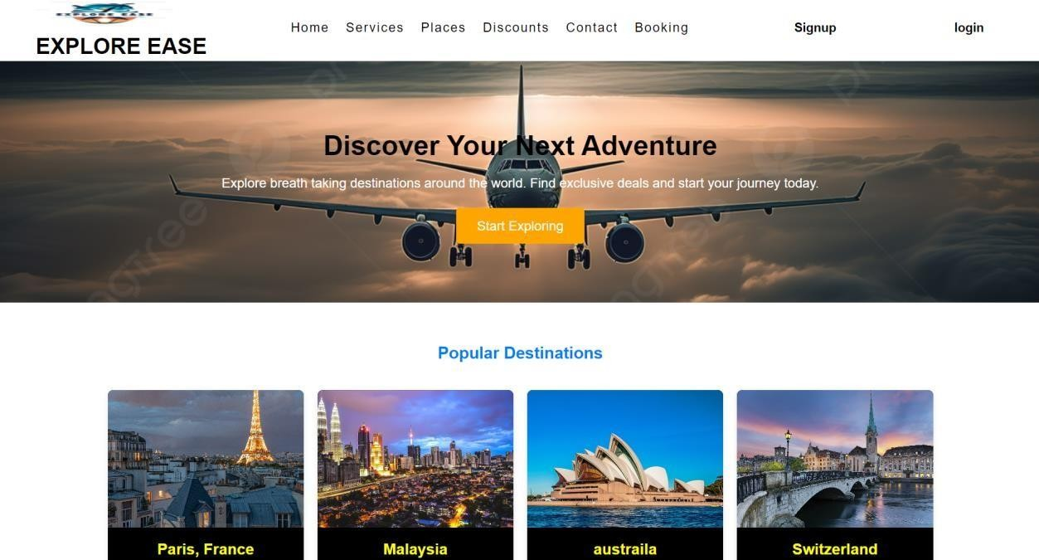

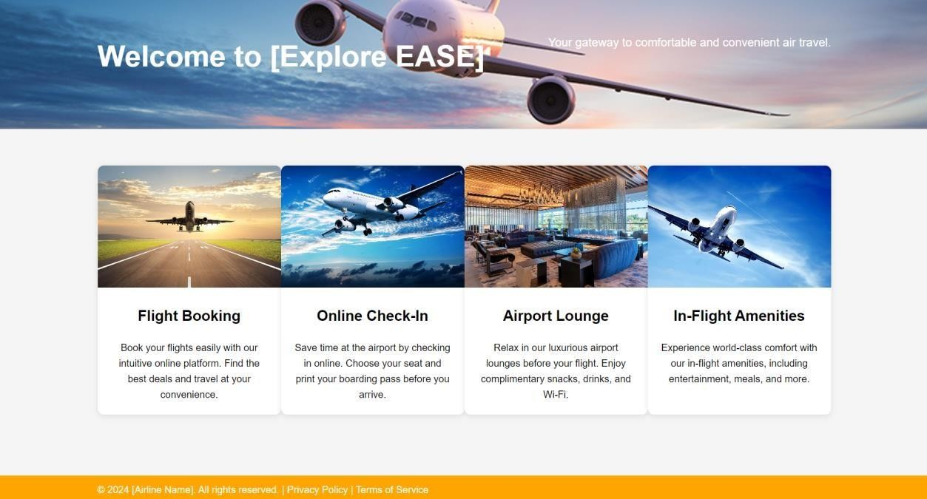

**Conclusion:**

### Project Description

Travel blog website is an engaging and informative platform where travel enthusiasts share their adventures, insights, and recommendations with a global audience. It serves as a rich resource for readers seeking inspiration and practical advice for their own journeys. The website typically features a variety of content, including detailed travel guides, personal travel stories, destination reviews, and tips on topics such as packing, budgeting, and local customs. Stunning visuals like photos and videos enhance the storytelling, allowing readers to experience destinations vicariously. The blog may also include interactive elements such as maps and itineraries to assist with trip planning. Beyond providing valuable information, a travel blog fosters a sense of community among travelers, offering a space for readers to interact, share experiences, and exchange travel tips. Through a combination of compelling content and user engagement, a travel blog website aims to inspire, inform, and connect a diverse audience of travel lovers.

### Practical Application

Travel blog website offers several practical applications that significantly enhance both user experience and operational efficiency. For users, the site serves as a valuable resource for travel planning and itinerary building, providing detailed destination guides, suggested itineraries, and practical tips for various travel needs. Interactive elements like maps and downloadable itineraries further assist readers in organizing their trips effectively. On the operational side, a content management system (CMS) allows bloggers to easily update and organize posts, ensuring that the site remains fresh and engaging with up-to-date information.

### Future Improvements

Future improvements for travel blog websites can significantly enhance user experience and adapt to emerging technologies and user preferences. One promising direction is the integration of artificial intelligence and machine learning to offer personalized content recommendations based on user behavior and past interactions. This could involve tailored travel itineraries, destination suggestions, and customized travel deals that cater specifically to individual preferences.